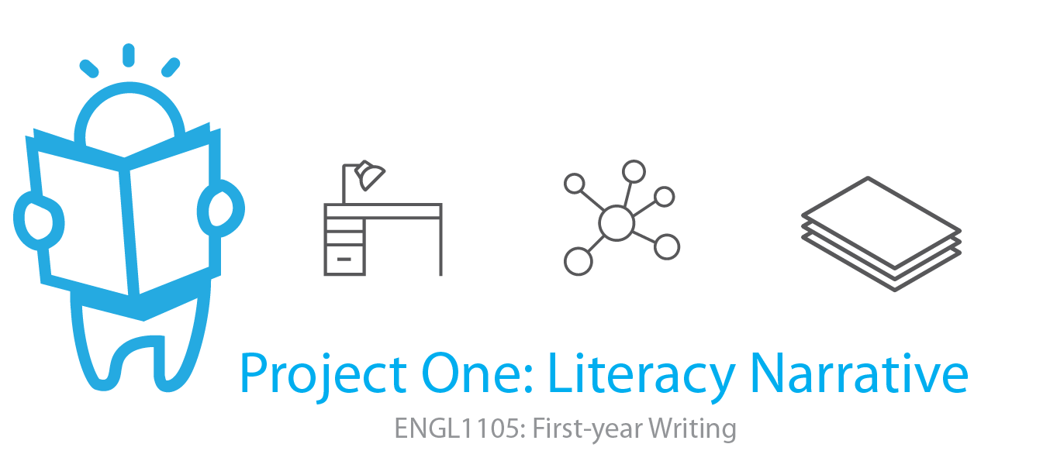
Overview
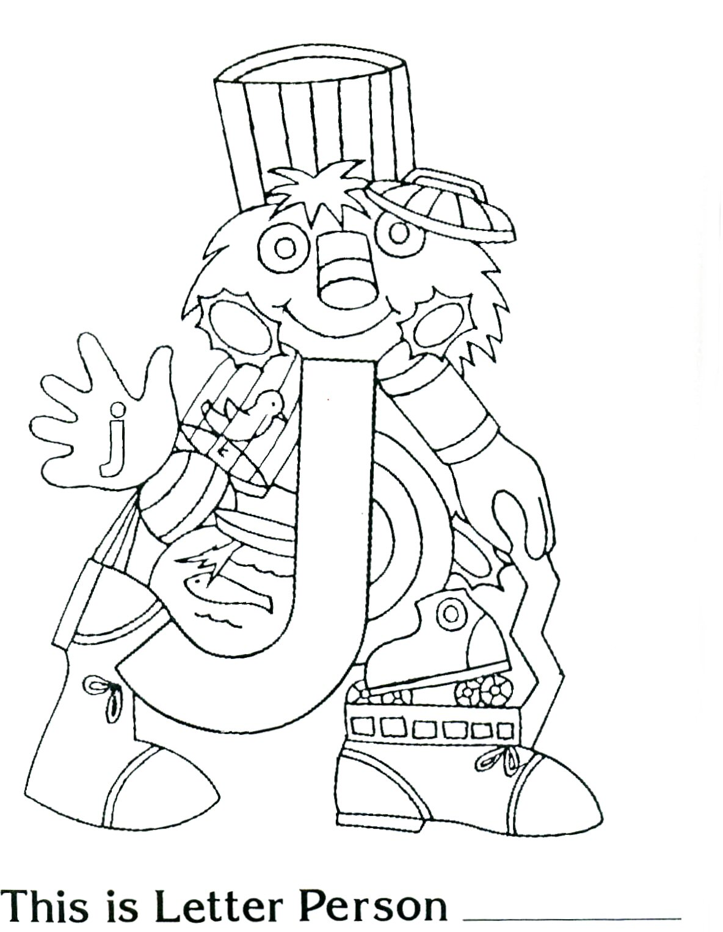
For the first project this semester you will develop a literacy narrative--an account of at least three formative literacy moments that together lead to insights about what literacy is and some of the reasons reading and writing habits are complex. Generally, literacy refers to fluencies with written language, and these fluencies are shaped by early and sustaining interactions with texts, observations of others who read and write in everyday life, and also the attitudes they project toward reading and writing. With this in mind, your project will be informed by memory work (or recalling personal history and experiences) and also by storytelling (or retelling brief narratives that include specific and carefully selected details). Successful literacy narratives will include memories told as stories in such a way that deepens, complicates, and even challenges assumptions about what everyday literacy entails.
Note that literacy is not always a pure positive. Sure, many snapshots of early childhood development depict privileged scenarios for reading and writing--children bouncing on the knees of grandparents who look like them, smiling faces all around, readily available materials that are almost always printed, never any signs of struggle, confusion, or frustration. But let's also acknowledge, by way of this project, that because literacy is also transformative, it includes conflict, discord, and even estrangement. That is, there are well-documented accounts of the ways learning to read and write more fluently can drive a wedge, even temporarily, between friends, family members, and co-workers, and operate as a source of hardship in transforming one's identity.
Successful projects will introduce snapshots of literacy development oriented to both the idyllic and the harsh, while also introducing a third way of thinking about literacy development. Think of this as a narrative project that situates literacy in three illustrative slices that together account for paradoxes and complexity in an evolving, multi-dimensional definition.
Generating Questions
- What is literacy? What materials (e.g., printed texts, device screens) are assumed to be operating in snapshots of literacy development? And which materials are not (e.g., a coach's marker board, sidewalk chalk, Snapchat)?
- How do three specific micro-narratives, or brief stories, deepen or complicate a basic sense of literacy as it has operated in your life?
- Who are some of the people who have sponsored your literacy development? What are some of the institutions that have urged you to become more fluent with language? Do you trust these people and institutions? In what senses did these people or institutions have your best interests at heart?
- When did you first learn to write? Read? Who was present? Who encouraged you? How did those interactions play out? Note, too, that although this is not a project that requires you to interview anyone or to collect artifacts, such as photos, you could enrich your account perhaps by talking to a family member, retrieving and analyzing a photograph of a scene of reading or writing from your childhood, and even including these in your literacy narrative.
- Have you encountered negative attitudes or statements toward literacy? Have you overheard or been subjected to discouraging or disparaging remarks about school literacy? When? From whom? How did you respond?
Your literacy narrative should be highly focused in its concern with three moments and the ways these moments lend depth and texture to what literacy means, to the ways literacy is not simple, to the ways it accords with the idyllic, the harsh, and at least one other quality. That is, it should acknowledge explicitly an evolving definition of literacy that taps into each narrative anecdote (or literacy moment) and that explores its significance, answering "So what?" more than once.
Deadlines and Specifications
- A half-draft of at least 500 words is due in your Google Folder (as a Google Doc) by the start of class on Wednesday, September 5.
- Project One and Invention Portfolio are due in your Google Folder by the start of class on Wednesday, September 12.
- At least four pages, typed and double-spaced (i.e., 1000 words)
- A title that adheres to the model, Catchphrase: Description, all the better if it has a playful, memorable turn of phrase in the first half
Focal Course Outcomes and Key Readings
Project One addresses all five course objectives, with special emphasis on Process, Conventions, and Reflection. Key readings include Chapters 1 and 3 from Understanding Rhetoric, your instructor's literacy narrative, Norma Mota-Allman's "Con Respeto," Devon Bohm's "In Love, In Grief, In Literature," and selections from Deborah Brandt's "Sponsors of Literacy."
Boosts (optional)
Boosts are value-added badges, of sorts. They offer you the incentive of doing something a little extra both to level-up your writing practice and also to gain experience with some aspect of development that will enrich your work. To claim a boost, simply add a note in your project at the location where you have applied the boost, like this [Boost One - Figure] or [Boost Two - Synthesis]. There are two boosts available for Project One. Each will also bear inflection in your project's evaluation, benefiting the project with a slight increase in credit.
Boost One - Figure
Incorporate an image and include beneath the image "Figure 1" and a descriptive caption. The image may be a copy of your literacy development map, or it may be a personal or family photograph that reflects reading or writing, or that indicates some location in which reading or writing materials were in the environment (e.g., a room with a book shelf).
Boost Two - Synthesis
Introduce and briefly synthesize one of the assigned readings for this project, account for it in relationship to the definitional work you are doing with literacy. That is, although you are not required to cite any sources for Project One, this boost encourages you to make direct reference to one of the sources we read, incorporating it into your writing with a leading phrase, following it with an in-text citation, and listing its reference details according to MLA in a Works Cited section at the end of the project.
Invention Portfolio Contents
(Note: This list may change at our time on the project unfolds.)
- Introduction handout (in-class 8/20)
- Three beliefs about writing exit ticket (in-class 8/20)
- Literacy development map (in-class 8/22)
- Literacy development map written account (homework 8/22)
- Copia - invention from lists (in-class 8/27)
- Figures unseen (sponsor cut-out) (in-class 8/29)
- Peer review (in-class 9/5)
- Half-draft (homework due 9/5)
- Invention Portfolio checklist (in-class 9/10)
- Reflective cover letter (in-class 9/12)
Grading Breakdown and Rubric
Grades for Project One will be returned to you on a grading worksheet (see a sample grading worksheet). It assigns values to the following criteria:
- Project One - Literacy Narrative
  - Evolving definition of literacy - The project introduces a definition of literacy that shifts and gains nuance as the project progresses.
  - Time-place specificity in three moments - Each narrative account includes specific details about time and place, sufficient to situate it and provide context.
  - Balanced and purposefully arranged moments - The narrative accounts are balanced (approximately equal length) and arranged with purpose.
  - Overall development (inc. title and length) - The project honors specifications concerning title, length, and any other formatting noted in class.
  - Correctness - The project reflects correctness.
- Invention Portfolio - Evaluated based on the pattern of checks, check-plusses, and check-minuses in the collection of work.
- Participation - Evaluated based on presence, attentiveness, attitude and disposition, willingness to engage in activities and in-class discussions
For a detailed schedule of class sessions throughout the timeframe of Project One: Literacy Narrative, visit the course schedule.

