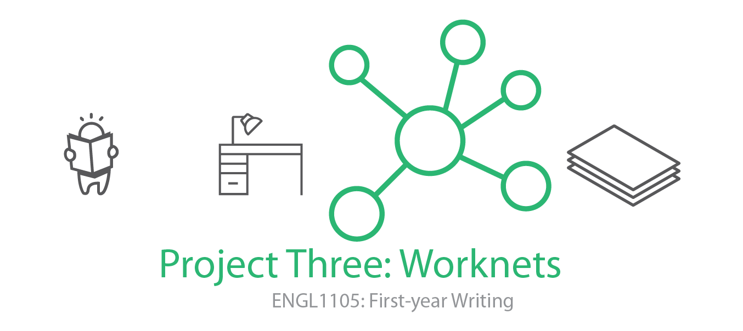Overview
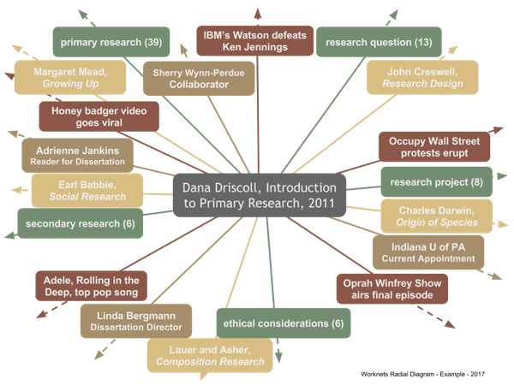
Figure 1: A completed worknet reflects four phases of the article: semantic,
bibliographic, affinity-based, and choric. Together they present a selection
of the article's entanglements.
Researched academic sources—articles and chapters—are a mainstay of many academic disciplines. They are the way academics account for research activity, posing difficult questions and detailing studies that seek to inform some research question, to share evidence, or to circulate findings. Without articles, how do ideas circulate? Word of mouth is far less reliable. Ideas, arguments, evidence: to survive in the world, to gain traction, build influence, to really matter, they must materialize. They need to be written. Project Three: Worknets introduces you to a method for reading and writing your way across one researched academic source carefully and thereby accounting for its generative connections. Worknets help readers comprehend and remember the important parts of an article, but they also prompt new researchable questions that can lead into emerging research interests for the reader. Importantly, worknets consist of a series of phases—four altogether—each expanding upon the article’s discoverable ties to keywords, sources, authorship, and the world (time and place) in which it was written. We should think of worknets as helping us engage sources visually and in writing so that we are better able to use the source toward rhetorical invention (i.e., toward coming up with what we will say). Worknets also help us grasp the rhetorical situation in which the article was produced—who wrote the article, what their purposes were, who was the audience, and how the article has circulated or been taken up.
How To Make A Worknet
Creating a worknet consists of three steps.
- Choose a researched academic article relevant to your area of inquiry published since 1980. I highly recommend that you work with one of the following titles, which you can access online:
Rewilding, "the Hoop," and Settler Apocalypse by Bruno Seraphin
https://www.erudit.org/en/journals/trumpeter/2016-v32-n2-trumpeter03384/1042989ar.pdf (Links to an external site.)Links to an external site.
Heritage Claims as a Civic Art for Rhetorical Circulation by Jonathan Bradshaw
http://enculturation.net/heritage_claims (Links to an external site.)Links to an external site.
Designing Captions: Disruptive Experiments with Typography, Color, Icons, and Effects by Sean Zdenek
http://kairos.technorhetoric.net/23.1/topoi/zdenek/index.html (Links to an external site.)Links to an external site.
Building Dark Patterns into Platforms: How GamerGate Perturbed Twitter's User Experience by Michael Trice and Liza Potts
http://www.presenttensejournal.org/wp-content/uploads/2018/06/Trice_Potts.pdf (Links to an external site.)Links to an external site.
Inoculating the Public: Managing Vaccine Rhetoric by Monica Brown
http://www.presenttensejournal.org/wp-content/uploads/2012/09/Brown.pdf (Links to an external site.)Links to an external site.
That Camera Won't Save You! The Spectacular Consumption of Police Violence by Armond R. Towns
http://www.presenttensejournal.org/wp-content/uploads/2015/12/Towns.pdf (Links to an external site.)Links to an external site.
Diversity, Technology, and Composition: Honoring Students' Multimodal Home Places by Christina V. Cedillo
http://www.presenttensejournal.org/wp-content/uploads/2017/08/Cedillo.pdf (Links to an external site.)Links to an external site.
Wicked Problems in Design Thinking by Richard Buchanan
https://www.jstor.org/stable/1511637 (Links to an external site.)Links to an external site.
- Next, open Google Drawing. It might take some time to get familiar with the drawing tools. We will spend time going over this in class. Important: Be sure to save a version of the model after each phase so you can easily show its build-up. Using a hub and spoke model, draw links from the central node (the article author, title, and year of publication) to a series of surrounding nodes. Create 3-5 nodes for each of the following four phases: semantic, bibliographic, affinity-based, and choric. The drawings should be done with care. Exceptional drawings will reflect precision insofar as legibility, spacing, color choices, and neatness. These phases are each explained below.
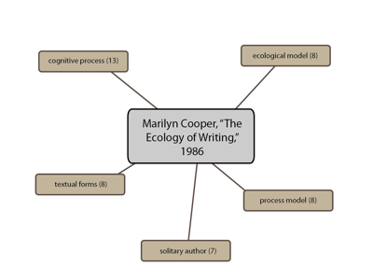
  - Semantic: concerns vocabulary—words and phrases that appear in the article itself and whose reference and meaning can be traced to peripheral ideas suited to further exploration. Whether you seek individual words or two-word phrases, include the total count in parentheses. There are online tools to help with this, such as Tagcrowd.com (Links to an external site.)Links to an external site. and the Online NGram Analyzer at http://guidetodatamining.com/ngramAnalyzer/ (Links to an external site.)Links to an external site.. In the written account that goes with the semantic phase, discuss what the terms mean, generally and in the context of the article. Why are these terms important? How do they advance the rhetorical goals of the piece? That is, how do the keywords favor a particular audience, showing that audience regard for forms of knowledge that is important to them?
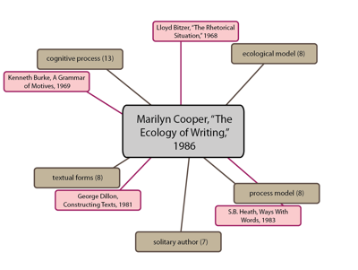
  - Bibliographic: traces specific sources cited in the original. For this phase, turn to the works cited or references list at the end of the article. Choose 3-5 sources. Are they available in Newman Library? What are the dates of publication? How do the sources appear in the article? That is, how are they being used? How might tracking down any one source expand your knowledge about the article and its rhetorical context? In what ways do specific sources advance the rhetorical goals of the piece?
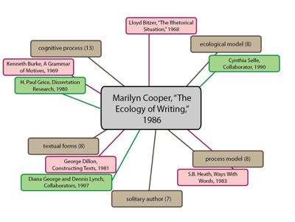
  - Affinity-based: attends to functions of authorship, such as graduate training, collaborations, current position, career arc for publishing activity, and relationship to other specializations. For the affinity-based phase, look up the author. What else has the author written? Do they publish by themselves or with others? What other work have they done? Does it seem to you related to the focus of this article? How so? Where does the author work? How long has she worked there? How does this knowledge give you a deeper sense of the author’s credibility, qualifications, or ethos?
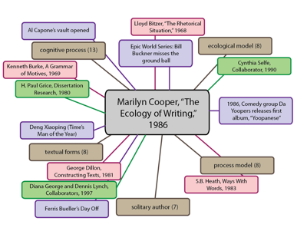
  - Choric: This phase examines the world in which the article was written, collecting a handful of popular culture references from the time and place it came from. Like the affinity worknet above, a choric worknet is not explicitly identifiable in the text of the article. It sets you up to explore coincident materials and events from popular culture (movies, songs, happenings, local and world news) in the interest of enlarging context and striking juxtaposition. What else, specifically, was happening when the article was written? What was going on in the place where it was written? How do a sample of these time-place associations open up new possibilities for exploring the article or an idea it introduces?
- A written account (approximately 350 words) accompanies each visual phase. That’s four phases, four accounts. Each account addresses the choices, responds to questions noted in association with each phase, and brings to light relevant noticings at that phase. Your completed project will also include an opening paragraph that introduces the article, and a concluding paragraph that discusses the article’s purpose, audience, and context using rhetorical terms and concepts we have discussed this semester (e.g., ethos, pathos, logos; kairos; rhetorical situation; audience, exigence, constraints).
Like Projects One and Two, your third project should be highly focused. All throughout, it will adhere to a single researched article. The project forecasts some of the work you will be doing in ENGL1106 next semester—selecting sources, reading them well, drawing upon them to reinforce your writing.
Deadlines and Specifications
- A half-draft of at least 800 words is due in your Google Folder (as a Google Doc) by the start of class on Monday, November 5.
- Project Three and Invention Portfolio are due in your Google Folder by the start of class on Wednesday, November 14.
- At least six pages, typed and double-spaced (i.e., 1600 words)
- A title that adheres to the model, Catchphrase: Description, all the better if it has a playful, memorable turn of phrase in the first half
- Required: Four visual worknet figures with appropriately developed captions
Focal Course Outcomes and Key Readings
Project Three addresses all five course objectives. Key readings include "How to Move In and Out of a Text” by Mueller, Clary-Lemon, and Pantelides, and an article of your choosing as the focus for the worknets.
Boost (optional)
Boosts are value-added badges, of sorts. They offer you the incentive of doing something a little extra both to level-up your writing practice and also to gain experience with some aspect of development that will enrich your work. To claim a boost, simply add a note in your project at the location where you have applied the boost, like this [Boost - Additional Worknet Model]. There is one boost available for Project Three. It will bear inflection in your project's evaluation, benefiting the project with a slight increase in credit.
Boost One - Additional Worknet Model
Develop an additional model of your worknet using either a) materials or b) 3D modeling. If you choose to make a material worknet, it may be helpful to think of it as something like a mobile, and to approach its development just that way, by looking into tutorials for making mobiles. If you want to make a 3D worknet, you will have to learn something about 3D modeling (or find others who can help with this). The purpose is to realize yet more voluminously the network-like structure this project underscores for academic sources.
Invention Portfolio Contents
(Note: This list may change as our time on the project unfolds.)
- 1. Worknets Reading Quiz (in-class 10/22)
- 2. Article Choice (homework 10/22)
- 3. Exit ticket fast-write (in-class 10/31)
- 4. Half-draft (homework due 11/5)
- 5. Peer review (in-class 11/5)
- 6. Invention Portfolio checklist (in-class 11/12)
- 7. Reflective cover letter (in-class 11/14)
Grading Breakdown and Rubric
Grades for Project Three will be returned to you on a grading worksheet much like Project One and Two. It assigns values to the following criteria:
- Project Three - Worknets
  - Hub and Spoke Visual Models- The project presents four hub and spoke models, carefully drawn and positioned, consistent with the respective phases, and legible.
  - Rhetorical analysis– The accounts make connections with purpose, audience, context, and timing. They make rhetorical terms explicit and demonstrate a grasp of the concepts.
  - Balanced and purposefully arranged accounts - The descriptive accounts are balanced (approximately equal length) and arranged with purpose.
  - Overall development (inc. title and length)- The project honors specifications concerning title, length, and any other formatting noted in class.
  - Correctness- The project reflects correctness.
- Invention Portfolio- Evaluated based on the pattern of checks, check-plusses, and check-minuses in the collection of work.
- Participation- Evaluated based on presence, attentiveness, attitude and disposition, willingness to engage in activities and in-class discussions

