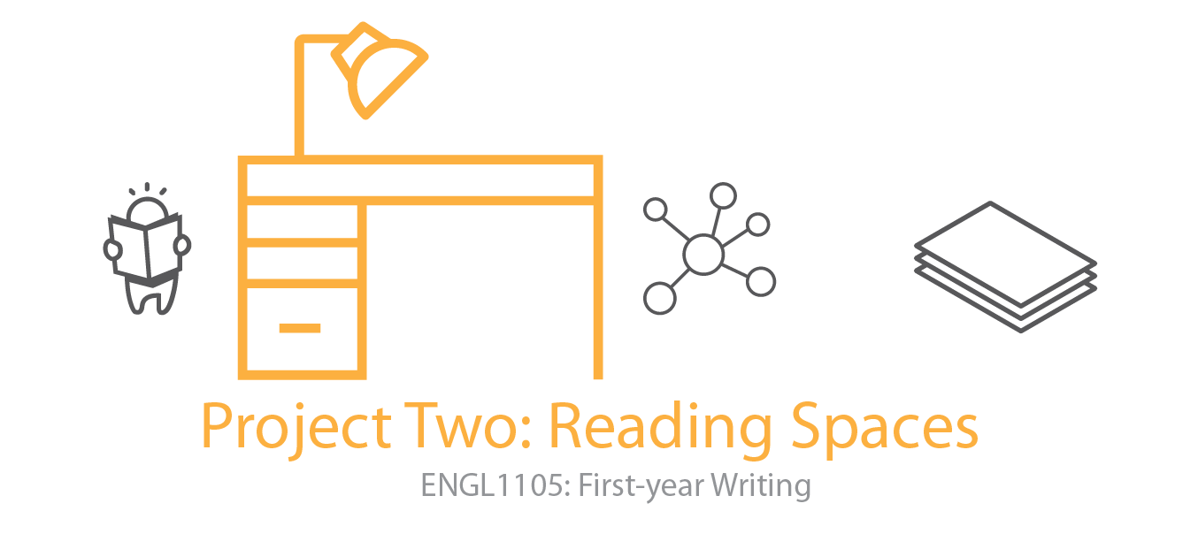
Overview
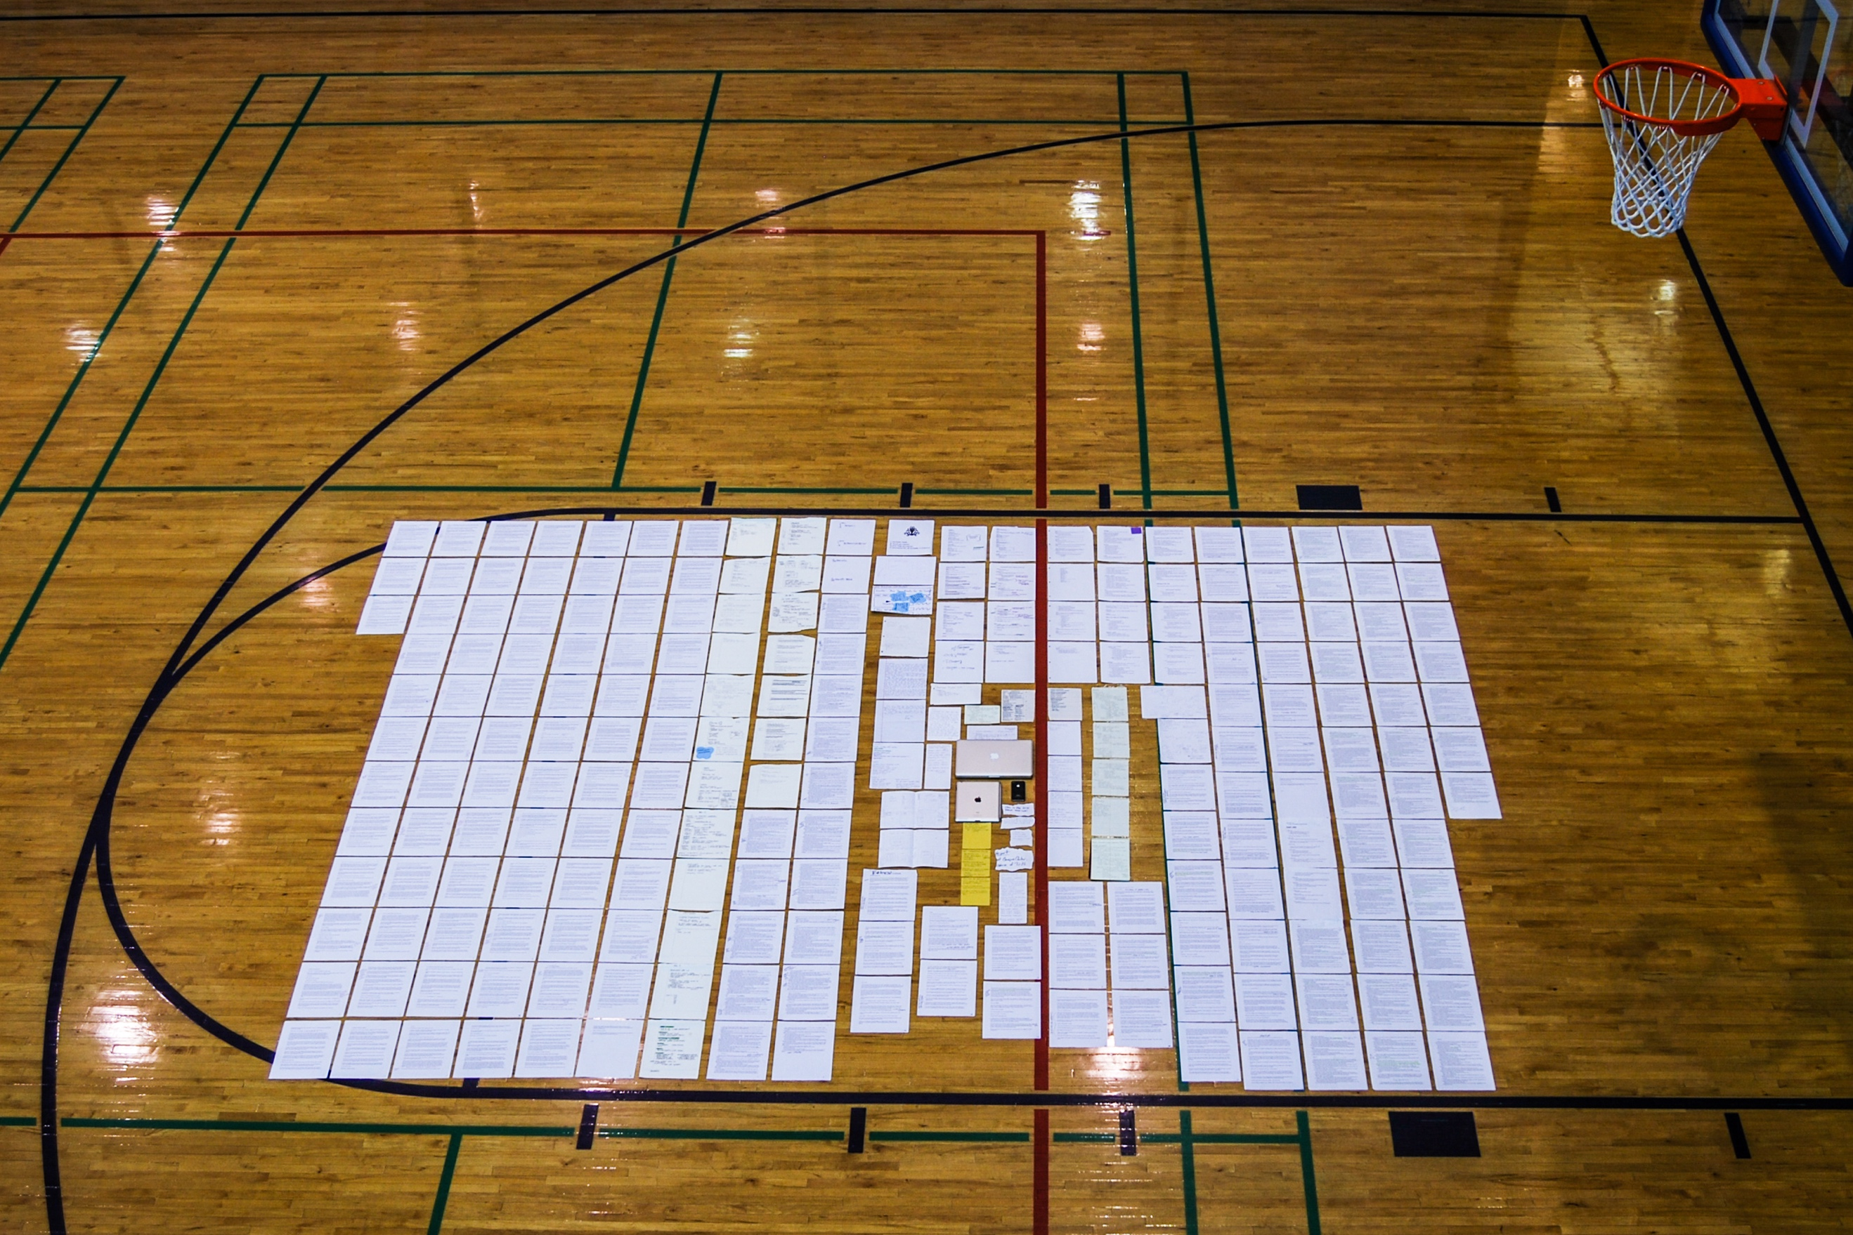
Figure 1. Dr. Brian McNely from University of Kentucky displays a genre
set, or a collection of documents, front and back, that interact in such
a way that each depends on the other to function and to do its part in
communicating about a complex issue. (photo shared with permission)
iGen students just don't read any more. Have you heard this? I have. Project Two seeks to dig into the assumptions beneath this provocation by calling for us to engage in what, exactly, first-semester students do read, how and where and why they read it, how much of it is self-sponsored and how much of it is assigned for class, how long you read for (in one sitting, for example, or while walking!), and what devices constitute the specific materials mediating this so-called reading. Whereas the literacy narrative in project one focused on the past, Project Two: Writing Spaces, focuses on the now, the moment you are in as a relatively new student at Virginia Tech.
Among the most basic first steps with a project such as this one will be to ask and answer, What is reading, anyway? Does it count as reading if I am on my iPhone, glancing Twitter or Instagram? Does it count as reading if I am leafing through the Collegiate Times. casually after lunch? Does it count as reading if I am not exactly living up to the idealized model of what a college student looks like when they are studying? And, on the other hand, what can you learn, what habits can you change, to become a more savvy and effective reader of a wide variety of texts while in college?
Early on, this project will ask you to inventory all of the reading you have been assigned this semester--textbooks, PDFs, handouts, both for class and for extracurricular activities, clubs, and sports. These are texts others have asked you to read. Just as is shown in Figure 1 above, you will spread these materials out, take a photo, and incorporate the photo into your project, captioning it as a photo and discussing it as a volume or set of reading you have been assigned. The photograph and its caption is not optional. This is an occasion to be distinctive with your work, too. Where and how will you present your photo(s) of all you've been assigned to read? Drill field? Dorm hallway? Screen shots? A combination of these?
But beyond this photo, your project will begin to analyze rhetorically the reading landscape in your first semester, the reading spaces that include
- materials: whether paper-based or electronic; some selected by you, some assigned by others;
- scenes: actual physical locations where you read, whether on foot as you stand or walk, at a desk or in a chair, in a crowded and noisy coffee shop, alone in a dormitory lounge;
- devices: the mediating means by which you read, whether on laptops, tablets, phones, or other devices; what devices are these, where did they come from, what are the applications you use to make them run well (for reading);
- habits: the time you take to read (in flitting moments or in blocks of time), the attitudes that come readily to you or that you struggle with, strategies you apply for navigating reading you are assigned to do, and tangible evidence of note-keeping or annotating the text, perhaps highlighting or writing in the margins to keep track of important points or to aid your memory.
Like Project One, your second project should be highly focused in its concern with at least three of these four points, accounting as fully as possible for the portrait of a reader in college--as someone who is still learning to read and for whom college has presented perhaps new challenges that require shifting strategies.
Deadlines and Specifications
- A half-draft of at least 700 words is due in your Google Folder (as a Google Doc) by the start of class on Wednesday, October 10.
- Project Two and Invention Portfolio are due in your Google Folder by the start of class on Wednesday, October 17.
- At least five pages, typed and double-spaced (i.e., 1400 words)
- A title that adheres to the model, Catchphrase: Description, all the better if it has a playful, memorable turn of phrase in the first half
- Required: One image or figure incorporated with a caption (image description)
Project Two addresses all five course objectives.
Boosts (optional)
Boosts are value-added badges, of sorts. They offer you the incentive of doing something a little extra both to level-up your writing practice and also to gain experience with some aspect of development that will enrich your work. To claim a boost, simply add a note in your project at the location where you have applied the boost, like this [Boost One - On Location Selfie] or [Boost Two - Social Media].There are two boosts available for Project Two. Each will also bear inflection in your project's evaluation, benefiting the project with a slight increase in credit.
Boost One - On Location Selfie
Take a photo of you reading in your favorite spot to read (ex. Sitting in Torg Bridge reading on a computer). Make sure you are reading something (textbook, eBook, novel) that you spend the majority of your time reading.
Boost Two - Social Media
Include a tweet and/or instagram/social media caption that goes along with your project. This caption should further your idea of what you are writing because this project is related to the way of how you read.
🚀 Boost Three - Sent Reflective Letter
In class on Wednesday, October 17, you will learn of a surprise-special-extra boost whereby you can send the reflective letter (bcc your instructor at instructoremail @vt.edu) for the rare (and never before offered) third boost.
Invention Portfolio Contents
(Note: This list was updated on October 14; it reflects accurately what should appear in your Invention Portfolio for Project Two.)
- Half Page on Project Two (for conference)
- Discerning Focuses Worksheet (homework due 9/26)
- Backtalk (Reader Response)
- Photographic evidence plan (in-class 9/26)
- Structuring Wild and Tame (in-class 10/3)
- Peer review (in-class 10/10)
- Half-draft (homework due 10/10)
- Invention Portfolio checklist (in-class 10/15)
- Reflective cover letter (in-class 10/17)
Grading Breakdown and Rubric
Grades for Project Two will be returned to you on a grading worksheet much like Project One. It assigns values to the following criteria:
- Project Two - Reading Spaces
  - Photographic evidence - The project presents compelling photographic evidence with detailed captions.
  - Specific accounts of three materials, scenes, devices, or habits - Each descriptive account includes specific details, sufficient to situate it and provide context.
  - Balanced and purposefully arranged moments - The descriptive accounts are balanced (approximately equal length) and arranged with purpose.
  - Overall development (inc. title and length) - The project honors specifications concerning title, length, and any other formatting noted in class.
  - Correctness - The project reflects correctness.
- Invention Portfolio - Evaluated based on the pattern of checks, check-plusses, and check-minuses in the collection of work.
- Participation - Evaluated based on presence, attentiveness, attitude and disposition, willingness to engage in activities and in-class discussions
For a detailed schedule of class sessions throughout the timeframe of Project Two: Reading Spaces, visit the course schedule.

